Adding a project to a repository

1. Go to the freeSCHEMA organization on github
   1. <https://github.com/orgs/FreeSchemaInc/dashboard>
2. Click “New Repository”
   1. 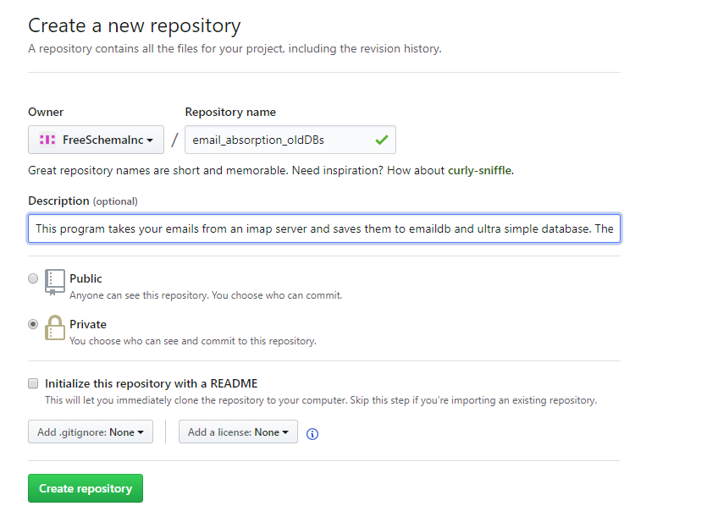
   2. Add a description
   3. Choose private repo
   4. Click create repo
   5. Make sure to initialize a read me
3. Create a folder on your local directory where your project files will go
   1. Clone the repository to your local machine using git bash
      1. 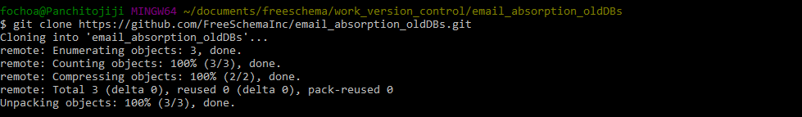
   2. Drag the desired project files and drag them onto the cloned folder on your local directory
   3. Now using git bash change directory and go into the master github folder that you just cloned
      1. 
4. Use the git commit command to commit the new files to the repository
   1. 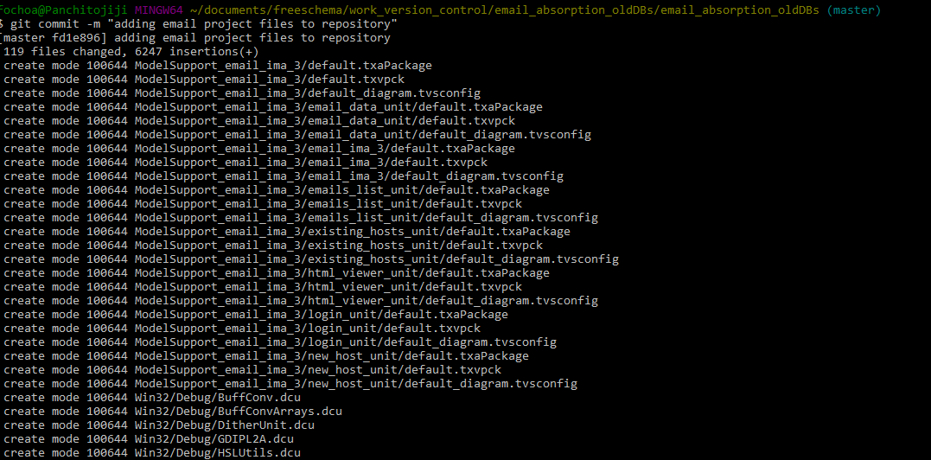
   2. 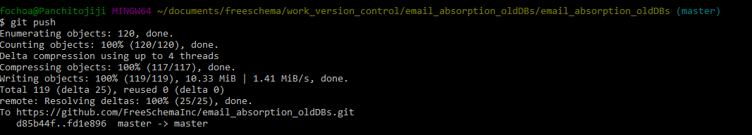
5. 